**Linha de Pesquisa Doença do Refluxo Gastroesofágico**

# Fatores associados a mortalidade por refluxo gastroesofágico: uma análise dos dados de São Paulo em 2020

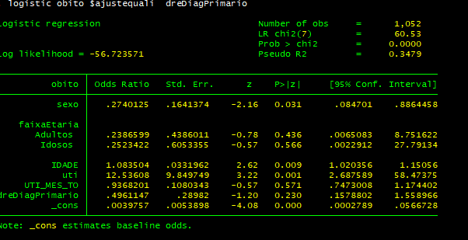

# Perfil epidemiológico de pacientes com refluxo gastroesofágico no SUS atendidos em São Paulo, 2020

**Tabulation of sexo**

|  |  |  |  |
| --- | --- | --- | --- |
| SEXO | Freq. | Percent | Cum. |
| Masculino | 561 | 51.47 | 51.47 |
| Feminino | 529 | 48.53 | 100.00 |
| Total | 1090 | 100.00 |  |
|  | | | |

**Tabulation of faixaEtaria**

|  |  |  |  |
| --- | --- | --- | --- |
|  | Freq. | Percent | Cum. |
| CrianÃ§as e Adolescentes | 516 | 49.05 | 49.05 |
| Adultos | 331 | 31.46 | 80.51 |
| Idosos | 205 | 19.49 | 100.00 |
| Total | 1052 | 100.00 |  |
|  | | | |

**Tabulation of raÃ§aCor**

|  |  |  |  |
| --- | --- | --- | --- |
| RACA_COR | Freq. | Percent | Cum. |
| Branca | 669 | 68.13 | 68.13 |
| Preta | 44 | 4.48 | 72.61 |
| Parda | 262 | 26.68 | 99.29 |
| Amarela | 6 | 0.61 | 99.90 |
| IndÃ­gena | 1 | 0.10 | 100.00 |
| Total | 982 | 100.00 |  |
|  | | | |

**Tabulation of obito**

|  |  |  |  |
| --- | --- | --- | --- |
| MORTE | Freq. | Percent | Cum. |
| NÃ£o | 1067 | 97.89 | 97.89 |
| Sim | 23 | 2.11 | 100.00 |
| Total | 1090 | 100.00 |  |
|  | | | |

**Tabulation of tipointernaÃ§Ã£o**

|  |  |  |  |
| --- | --- | --- | --- |
|  | Freq. | Percent | Cum. |
| Eletivo | 319 | 29.32 | 29.32 |
| UrgÃªncia | 769 | 70.68 | 100.00 |
| Total | 1088 | 100.00 |  |
|  | | | |

**Tabulation of tratamentoCirurgico**

|  |  |  |  |
| --- | --- | --- | --- |
|  | Freq. | Percent | Cum. |
| NÃ£o | 975 | 89.45 | 89.45 |
| Sim | 115 | 10.55 | 100.00 |
| Total | 1090 | 100.00 |  |
|  | | | |

**Tabulation of uti**

|  |  |  |  |
| --- | --- | --- | --- |
|  | Freq. | Percent | Cum. |
| NÃ£o | 866 | 79.45 | 79.45 |
| Sim | 224 | 20.55 | 100.00 |
| Total | 1090 | 100.00 |  |
|  | | | |

**Tabulation of dreDiagPrimario**

|  |  |  |  |
| --- | --- | --- | --- |
|  | Freq. | Percent | Cum. |
| SecundÃ¡rio | 415 | 38.07 | 38.07 |
| PrimÃ¡rio | 675 | 61.93 | 100.00 |
| Total | 1090 | 100.00 |  |
|  | | | |

**Summary statistics**

|  |  |  |  |  |  |
| --- | --- | --- | --- | --- | --- |
|  | Mean | Std. Dev. | Median | p25 | p75 |
| IDADE | 27.926 | 27.554 | 16 | 3 | 53 |
| DIAS PERM | 8.984 | 14.702 | 4 | 2 | 9 |
| UTI MES TO | 2.606 | 8.598 | 0 | 0 | 0 |
| DIAR ACOM | 3.255 | 7.862 | 0 | 0 | 3 |
| QT DIARIAS | 6.047 | 9.758 | 3 | 1 | 6 |

# Fatores associados a sobrevida de pacientes com refluxo gastroesofágico atendidos na UTI do sus em São Paulo, 2020

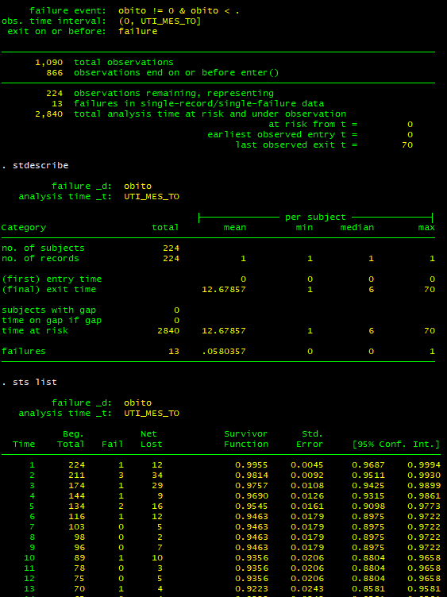

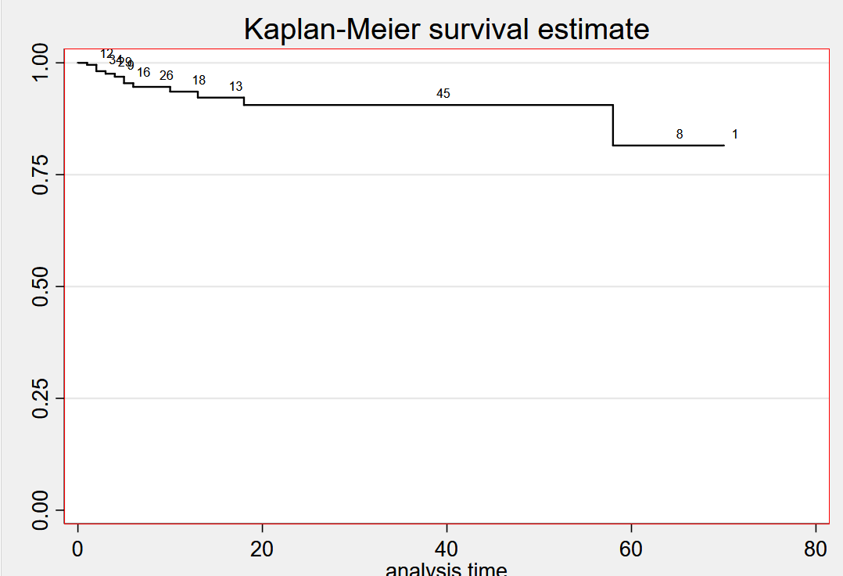

# Determinantes do custo com tratamento de pacientes com refluxo gastroesofágico no sus em São Paulo no ano 2020

**Descriptive Statistics**

|  |  |  |  |  |  |
| --- | --- | --- | --- | --- | --- |
| Variable | Obs | Mean | Std. Dev. | Min | Max |
| VAL_SH | 1090 | 2105.515 | 4774.804 | 30.47 | 45679 |
| VAL_SP | 1090 | 429.881 | 953.987 | 8.15 | 9795.93 |
| VAL_TOT | 1090 | 2535.396 | 5665.813 | 40.38 | 53506.97 |
| VAL_UTI | 1090 | 1421.269 | 4768.589 | 0 | 44520.96 |
|  | | | | | |